**Secção de Motociclismo: Visita ao Forte da Graça**

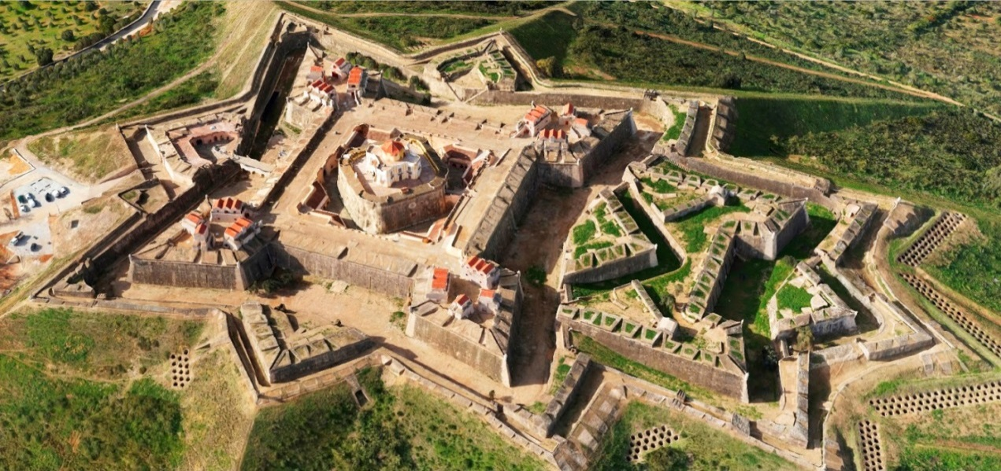

A **Secção de Motociclismo do GDC Fidelidade** organiza no dia **28 de Abril** (sábado)uma visita ao **Forte da Graça**, em Elvas.

O Forte da Graça foi mandado construir por D. José I, no monte onde se encontrava a antiga capela de Nossa Senhora da Graça. O monte da Graça é um dos pontos mais altos da região, constituindo portanto um local de grande importância estratégica.

O almoço será no restaurante ***Vinha da Amada***, em Elvas.

**Ementa**: Pão / Queijo / Azeitonas; Bacalhau c/ espinafres; Cozido de grão

**Sobremesa**: Sericaia ou outro doce

**Bebida**: Vinho Monte das Servas / Águas

Os colegas interessados em participar deverão contactar, até dia **24 de Abril**, o colega João Camilo.

email: [jcamilo.pereira@gmail.com](mailto:jcamilo.pereira@gmail.com)

**Local de saída**: Lisboa (a combinar), pelas 8 horas da manhã.

|  |  |
| --- | --- |
| **Sócios** | **Não Sócios** |
| **10,00€** | **20,00€** |

|  |  |  |  |  |  |  |  |  |  |  |  |  |  |  |  |  |  |  |  |  |  |  |  |  |  |  |  |  |  |  |  |  |  |  |  |  |  |  |  |  |  |  |  |  |  |  |  |  |  |  |  |  |  |  |  |  |  |  |  |  |  |  |  |  |  |  |  |  |  |  |  |  |  |  |  |  |  |  |  |  |  |  |  |  |  |  |  |  |  |  |  |  |  |  |  |  |  |  |  |  |  |  |  |  |  |  |  |  |  |  |  |  |  |  |  |  |  |  |  |  |  |  |  |  |  |  |  |  |  |  |  |
| --- | --- | --- | --- | --- | --- | --- | --- | --- | --- | --- | --- | --- | --- | --- | --- | --- | --- | --- | --- | --- | --- | --- | --- | --- | --- | --- | --- | --- | --- | --- | --- | --- | --- | --- | --- | --- | --- | --- | --- | --- | --- | --- | --- | --- | --- | --- | --- | --- | --- | --- | --- | --- | --- | --- | --- | --- | --- | --- | --- | --- | --- | --- | --- | --- | --- | --- | --- | --- | --- | --- | --- | --- | --- | --- | --- | --- | --- | --- | --- | --- | --- | --- | --- | --- | --- | --- | --- | --- | --- | --- | --- | --- | --- | --- | --- | --- | --- | --- | --- | --- | --- | --- | --- | --- | --- | --- | --- | --- | --- | --- | --- | --- | --- | --- | --- | --- | --- | --- | --- | --- | --- | --- | --- | --- | --- | --- | --- | --- | --- | --- | --- |
| **Ficha de Inscrição** | | | | | | | | | | | | | | | | | | | | | | | | | | | | | | | | | | | | | | | | | | | | | | | | | | | | | | | | | | | | | | | | | | | | | | | | | | | | | | | | | | | | | | | | | | | | | | | | | | | | | | | | | | | | | | | | | | | | | | | | | | | | | | | | | | | |
|  | |  | |  | |  |  | | |  | |  | | |  | |  | |  | | |  | |  | |  | |  | | |  | | |  |  | | |  | | |  |  | | |  | | |  | | |  | |  | | |  | | |  | |  | |  | | |  | | | |  | |  | | |  | | | |  | | | |  | |  | | | | | | | | | | |  | | | | |  |  | | | |  | | | | | | | |  | |  | | | | |  | | |  | |  | |  | | |  |  | |  | | | | |
| **Nome:** | | | | | |  | | | | | | | | | | | | | | | | | | | | | | | | | | | | | | | | | | | | | | | | | | | | | | | | | | | | | | | | | | | | | | | | | | | | | | | | | | | | | | | **Nº Sócio:** | | | | | | | | | | | | | | | | |  | | | | | | | | | | | | | | | | | | | | | | | | | | |  |  | |  | | | | | | | | | | | | | | | | | | | | | | | | | | |
|  | | | | | | | | | | | | | | | | | | |  | | |  | |  | |  | |  | | |  | | |  |  | | |  | | |  |  | | |  | | |  | | |  | |  | | |  | | |  | |  | |  | | |  | | | |  | |  | | |  | | | | |  | | |  | |  | | | | | | | | | | |  | | |  | | |  | | | |  | | | | | | | |  | |  | | | | |  | | |  | |  | |  | | |  |  | |  | | | | | | | | | | | | | | | | | | | | | | | | | | | | | | | |
| **Data Nasc:** | | | | | | | | | |  | | | | | | | | | | | | | | | | | | | | | | | | | **NIF:** | | | | | | | | | | | | | |  | | | | | | | | | | | | | | | | | | | | | | | | | | | | | | | | | | | |  | | | | | | | | | | | | | |  | | |  | | | |  | | | | | | | |  | |  | | | | |  | | |  | |  | |  | | |  |  | |  | | | | | | | | | | | | | | | | | | | | | | | | | | | | | | | |
|  | |  | |  | |  |  | | |  | |  | | |  | |  | |  | | |  | |  | |  | |  | | |  | | |  |  | | |  | | |  |  | | |  | | |  | | |  | |  | | |  | | |  | |  | |  | | |  | | | |  | |  | | |  | | | | |  | | |  | |  | | | | | | | | | | |  | | |  | | |  | | | |  | | | | | | | |  | |  | | | | |  | | |  | |  | |  | | |  |  | |  | | | | | | | | | | | | | | | | | | | | | | | | | | | | | | | |
| **Outros Participantes:** | | | | | | | | | | | | | | | | | | | | | | | | | | | | | | | | | |  |  | | |  | | |  |  | | |  | | |  | | |  | |  | | |  | | |  | |  | |  | | |  | | | |  | |  | | |  | | | | |  | | |  | |  | | | | | | | | | | |  | | |  | | |  | | | |  | | | | | | | |  | |  | | | | |  | | |  | |  | |  | | |  |  | |  | | | | | | | | | | | | | | | | | | | | | | | | | | | | | | | |
|  | | | | | | | | | | | | | | | | | | | | | | | | | | | | | | | | | | | | | | | | | | | | | | | | | | | | | | | | | | | | | **Data Nasc:** | | | | | | | | | | | | | | | |  | | | | | | | | | | | | | | | | | **Sócio Nº:** | | | | | | | | | | | | | | | | | |  | | | | | | | | | | | | | | | **Não** | | | |  |  | |  | | | | | | | | | | | | | | | | | | | | | | | | | | | | | | | |
|  | | | | | | | | | | | | | | | | | | | | | | | | | | | | | | | | | | | | | | | | | | | | | | | | | | | | | | | | | | | | | | | | | | | | | | | | | | | | | | | | | | |  | |  | | | | | | | | | | |  | | |  | | |  | | | |  | | | | | | | |  | |  | | | | |  | | |  | |  | |  | | |  |  | |  | | | | | | | | | | | | | | | | | | | | | | | | | | | | | | | |
|  | | | | | | | | | | | | | | | | | | | | | | | | | | | | | | | | | | | | | | | | | | | | | | | | | | | | | | | | | | | | | **Data Nasc:** | | | | | | | | | | | | | | | |  | | | | | | | | | | | | | | | | | **Sócio Nº:** | | | | | | | | | | | | | | | | | |  | | | | | | | | | | | | | | | **Não** | | | |  |  | |  | | | | | | | | | | | | | | | | | | | | | | | | | | | | | | | |
|  | | | | | | | | | | | | | | | | | | | | | | | | | | | | | | | | | | | | | | | | | | | | | | | | | | | | | | | | | | | | | | | | | | | | | | | | | | | | | | | | | | |  | |  | | | | | | | | | | |  | | |  | | |  | | | |  | | | | | | | |  | |  | | | | |  | | |  | |  | |  | | |  |  | |  | | | | | | | | | | | | | | | | | | | | | | | | | | | | | | | |
| **Email:** | | | | | |  | | | | | | | | | | | | | | | | | | | | | | | | | | | | | | | | | | | | | | | | | | | | | | | | | | | | | | | | | | |  | | | | | | | | | | | | | | | | | | | | | | | | | | | |  | | | |  | | | | | | |  | | | |  | | | | | |  | | | | |  | | | | | |
|  | | | | | | | | |  | | | |  | | |  | | | |  | | |  | | |  | | |  | | |  | | | | |  | | |  | | |  | | |  | | | |  | | | |  | | |  | | |  | | | |  | | | |  | | |  | | |  | | | |  | | | |  | | | |  | |  | |  | |  | | |  | | | | |  | | | |  | | | |  | | |  | | | | | | |  | | | |  | | |  | | | | | | | | | | |  | |  | | | | |  | |  | | |  | |  | |  | |  | |  | |  | | |  | |  | |  |
| **Pagamento:** | | | | | | | | | | **Venc.** | | | | | | | | | | | | | | | |  | | | **Numerário** | | | | | | | | | | | | | | | | | | | | | | | | |  | | | **T. B. – 003521790001079833036** | | | | | | | | | | | | | | | | | | | | | | | | | | | | | | | | | | | | | | | | | | | | | | | | | | | | | |  | |  | | | | | | | | | | | | | | | | | | | | | | | | | | | |  | | |  | |
|  | | |  | |  | | |  | | |  | | |  | | | |  | | |  | | | |  | |  | | |  | | |  | | |  | | |  | | | | |  | | |  | | | | |  | | |  | | |  | | | |  | | |  | | | |  | | | |  | | |  | | | | |  | | | | | |  | |  | |  | |  | | | |  | | | | | |  | | | |  | | |  | | | | | | | | |  | | | |  | | | | | | | | | |  | | | |  | | |  | |  | | | | |  | |  | |  | |  | |  | |  | | |  | |  | |  | |
| **Assinatura:** | | | | | | | | | |  | | | | | | | | | | | | | | | | | | | | | | | | | | | | | | | | | | | | | | | | | | | | | | | | | | | | | | | | | **Telemóvel:** | | | | | | | | | | | | | | | | |  | | | | | | | | | | | | | | | | | | | | | | | **Data:** | | | | | | | | | |  | | | | | | | | | | | | | | | |  | |